PE05 – Shila Jahanbin

Create Recipe
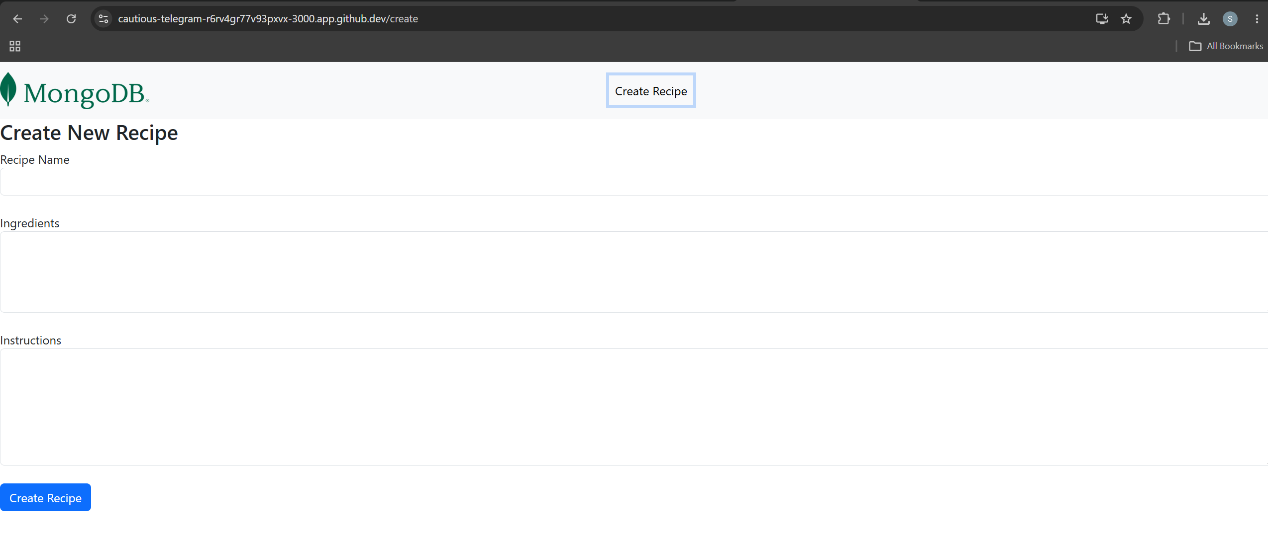

Insert data
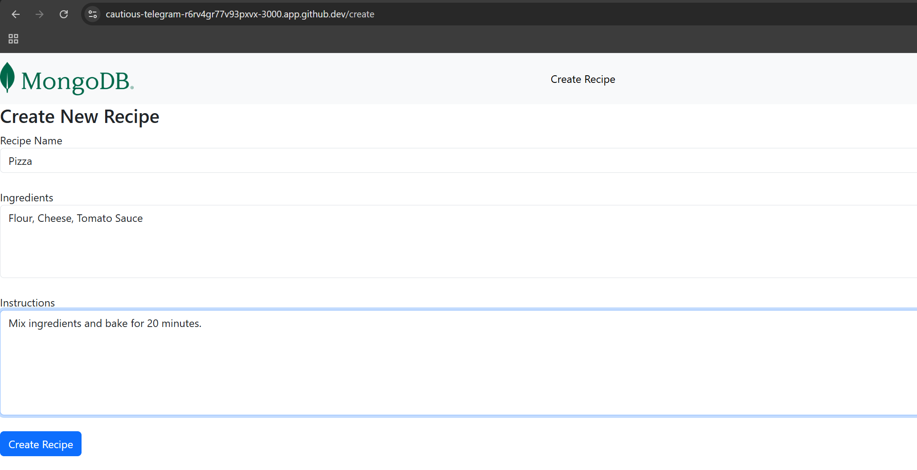

View List
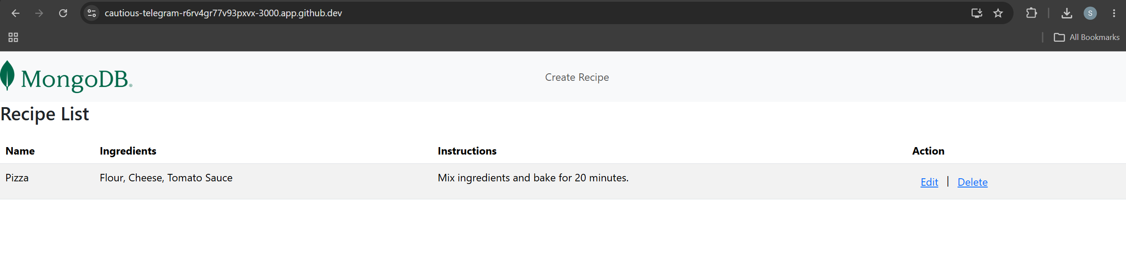
Update the recipe
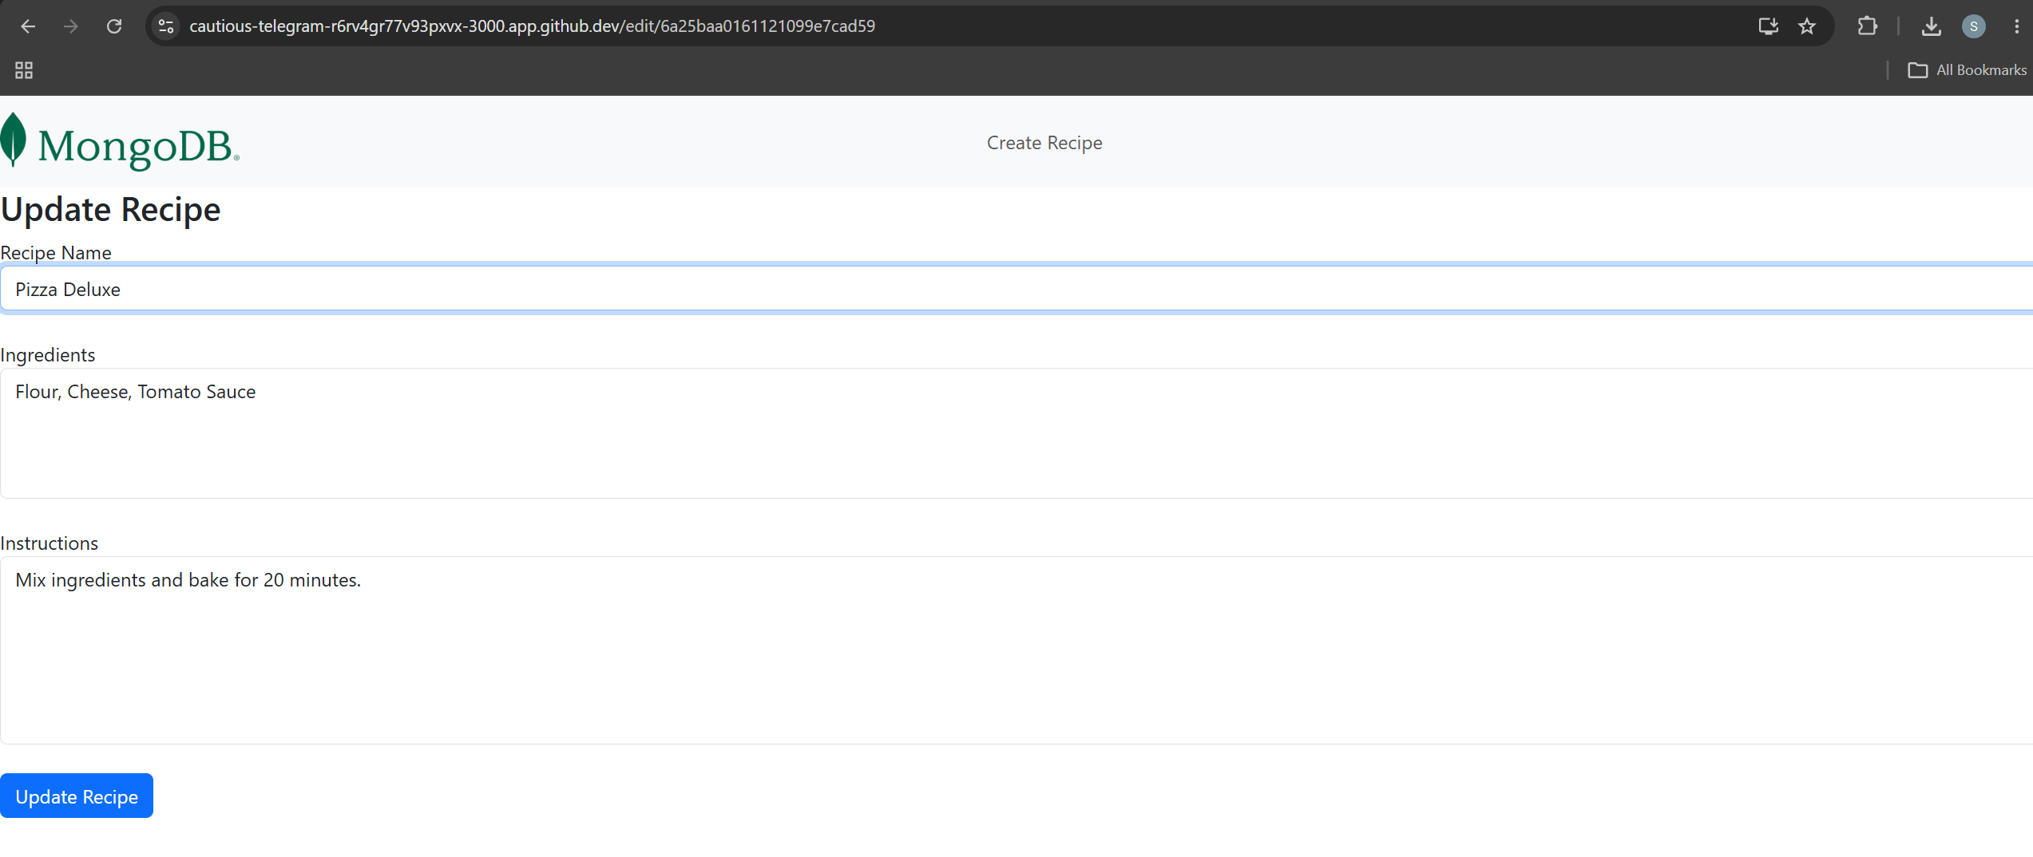
After Update:
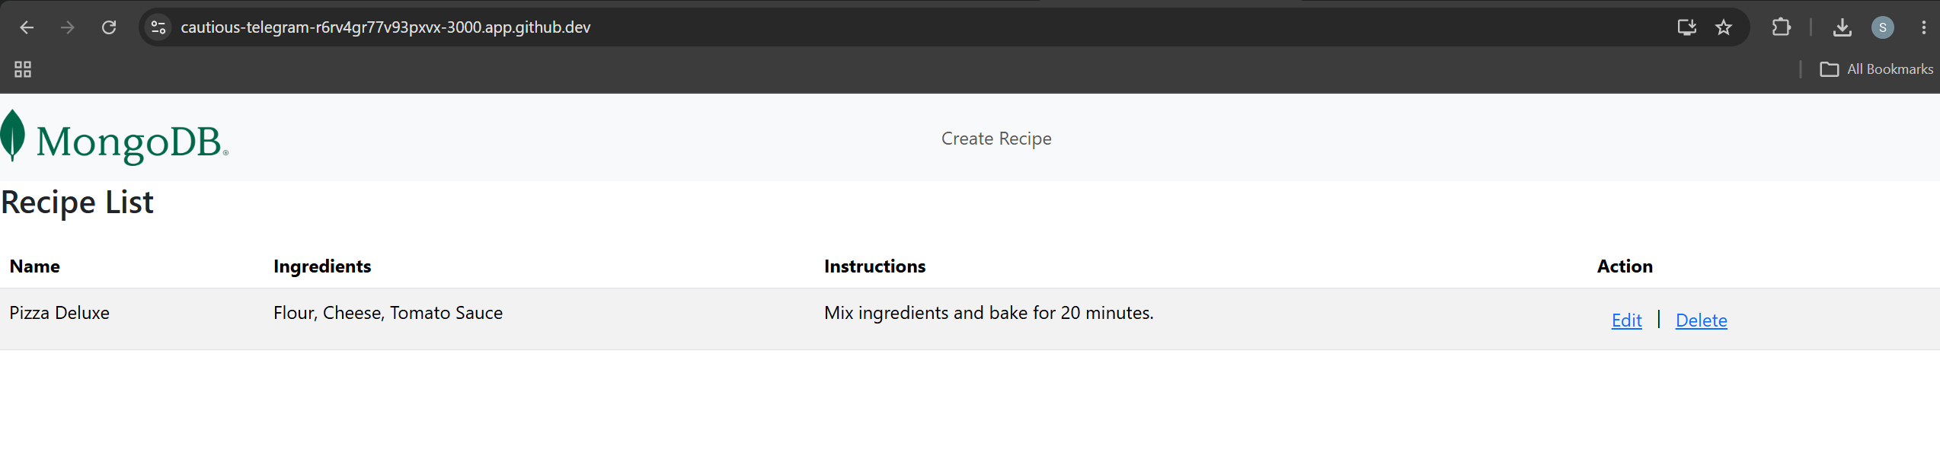

After Delete:
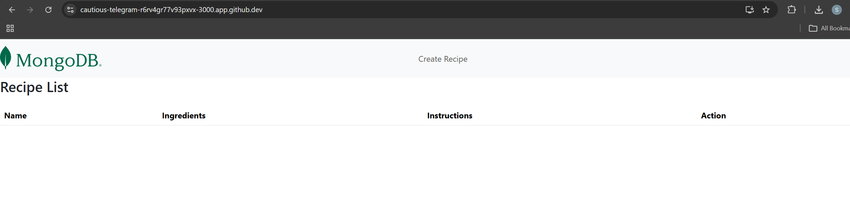

Screenshots of records in MongoDB:
